**Understanding the code**

**Selenium Webdriver**

<https://www.javadoc.io/doc/org.seleniumhq.selenium/selenium-api/2.50.1/org/openqa/selenium/WebDriver.html>

Using the outline, we can see our global variables (blue triangles) and methods(green circles) for this class

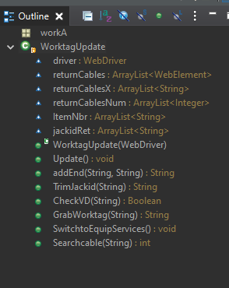

**What is a method?**

A method is a block of code which only runs when it is called. You can pass data, known as parameters, into a method. Methods are used to perform certain actions, and they are also known as functions.

See more here: <https://www.w3schools.com/java/java_methods.asp#:~:text=A%20method%20is%20a%20block,are%20also%20known%20as%20functions>.

**What is a global variable?**

A variable holds data. Global means you can access it in any method. The arrayList type we use above just holds a list

**What each method and global variable do**

* driver
  + Webdriver, used when grabbing anything from mysoft
* returnCables
  + when a cable is searched on mysoft, this will store
* returnCablesX
  + when a cable is searched on mysoft, this will store The Xpath for each returned value. The xpath is the HTML path needed if we wanted to click into the element in mysoft
* returnCablesNum
  + when a cable is searched on mysoft, this will store the number in which each element was found
* ItemNbr
  + when a cable is searched on mysoft, this will store the ItemNbr for each returned value
* jackidRet
  + when a cable is searched on mysoft, this will store the jackID that mysoft has stored got each returned row
* WorktagUpdate(WebDriver d)
  + Constructor, this just allows use to use the same webdriver we used in Auto.java
* Update()
  + This is the main method where the bulk of work happens. All the methods below are called from this method
  + Inside the while loop
    - This will loop through every jack in the cutsheet. While loop basically meaning – while there are jacks still left in the excel sheet
  + Follow the annotated code within the file for more details
* Addend(String cutsheetID, String retjackidStr)
  + This will add the -D to the end of the jack if needed
* TrimJackid(String jackid)
* CheckVD(String jackid)
* GrabWorktag(String x)
* SwitchtoEquipServices()
* Searchcable(String cable)
  + This will search mysoft for the cable, and populate the global variables listed above. This method will ignore any returns with an end date

**Common Selenium webdriver methods used and Exceptions**

* Stale Elements exception

**Changing how worktags are labeled**

For changing how worktags are labeled we will look at this part of the code

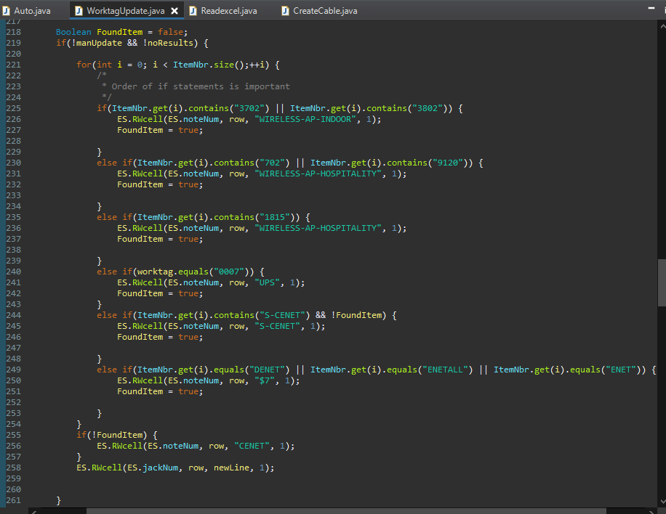

**Modifying other sections of the code**

**Grabbing Xpath**